THEORY QUESTIONS

- Insert Operations
insertOne() is used to insert a single document into a mongoDB collection.
MongoDB command to insert a single document into a collection.
db.students.insertOne({
name: “Saara”,
age: 22,
course: “Computer Science”
})

insertMany() is used to insert multiple documents at once, whereas insertOne() inserts only one document.

What happens if only one document fails during insertMany() execution?
- By default, MongoDB stops inserting further documents.
- If ordered : false is used, MongoDB continues inserting remaining documents.

- Update Operations
updateOne() updates only one matching document, while updateMany() updates all matching documents.
Command to update only one document’s field in MongoDB:
db.students.updateOne(
{ name: “Saara” },
{ $set: { age: 23 } }
)
Update multiple documents at the same time:
db.students.updateMany(
{ course: “Computer Science” },
{ $set: { status: “Active” } }
)

What happens if the filter condition is updateOne() matches multiple documents?
Only the first matching document is updated.
What update operator is used to modify specific fields without replacing the entire document?
The $set operator is used.

- Add Date (Current Date)
db.orders.insertOne({
product: “Laptop”,
orderDate: ISODate()
})

Which operator is equivalent to SQL CURDATE()?
ISODate() or new Date()

Command to add the current date to all existing documents:
db.logs.updateMany(
{}, { $currentDate: { updatedAt: true} }
)

Difference between using new Date() and $currentDate:
- new Date() is used during insert or update
- $currentDate is used only during update and is set automatically by MongoDB.

- Delete Operations
deleteOne() deletes one document, while deleteMany() deletes multiple documents.
db.students.deleteOne({ name: “Saara” })

What happens if the filter in deleteMany() is empty {} ?
All documents in the collection are deleted, but the collection remains.
- Drop Operations
How do you drop a collection?
db.students.drop()
Command to drop and entire database:
db.dropDatabase()
Difference between deleteMany() and drop():
- deleteMany() removes all documents but keeps the collection
- drop() deletes the entire collection including indexes.

PRACTICAL QUESTIONS
(CRUD)

- insertOne (Practical)
Insert a student record with name, course, and year. Insert an employee document with name, role, salary, and joining date. Create a product document with name, price, and category.
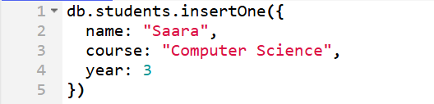
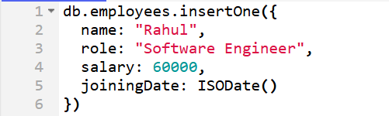
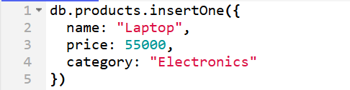

- insertMany (Practical)
Insert at least 5 user records into a collection. Insert multiple products belonging to different categories. Insert many orders with orderId, customerName, and totalAmount.
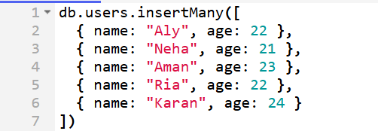
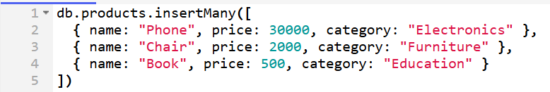
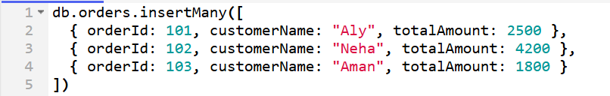

- updateOne (Practical)
Update the salary of a single employee. Add a new field status to one specific user. Change the city of one customer.
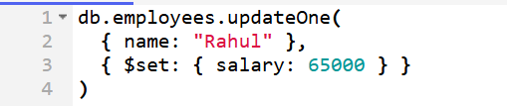
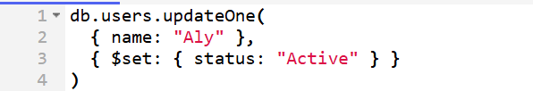
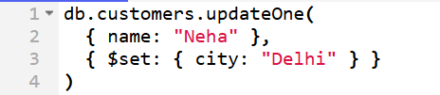

- updateMany (Practical)
Add a field updatedDate with the current date to all records. Increase the price of all products in a specific category. Add a new field country to all users.
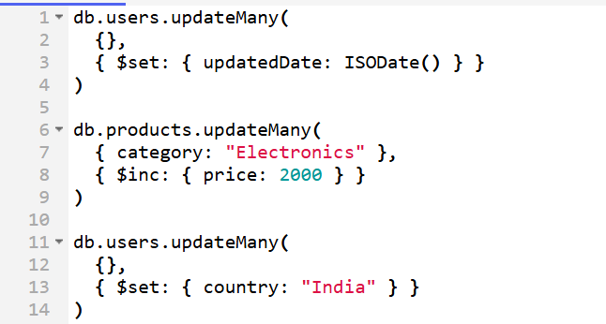

- Add Date (Practical)
Insert a document with the current date using MongoDB. Update all documents by adding today’s date. Convert a numeric year field into a date field.
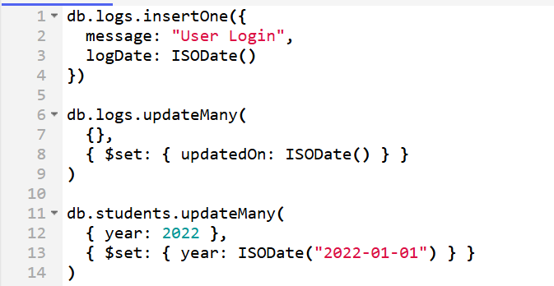

- deleteOne (Practical)
Delete a user whose name is "Aly". Remove one product with a specific productId.


- deleteMany (Practical)
Delete all users from a particular city. Delete all records where the year is less than 2020.
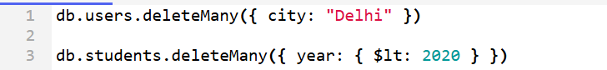

- Drop Operations (Practical)
Drop a collection named students. Drop the current database.


